AI WEATHERWISE API

Intelligent Weather Forecasting and Monitoring System

Submitted By Team 14
S.NO | Team Member Name | Role
1 | Sanmathi Kumar | Team Leader
2 | Arifa Zohra | Team Member
3 | Ainul Liyana P.M | Team Member
4 | Vaishali S | Team Member
Department of Computer Applications (BCA)
Chevalier T. Thomas Elizabeth College for Women
Academic Year: 2026–2027

Table of Contents
- Abstract
- Introduction
- Problem Statement
- Objectives
- Scope of the Project
- Technology Stack
- System Architecture
- Modules Description
- Database Design
- Features
- Project Workflow
- Advantages
- Limitations
- Future Enhancements
- Conclusion
- References

Abstract
AI WeatherWise API is a weather forecasting and monitoring application developed to provide real-time weather information through a user-friendly interface. The system integrates weather APIs to retrieve weather data such as temperature, humidity, wind speed, atmospheric pressure, and weather conditions. The application is developed using Node.js, Express.js, MongoDB Atlas, HTML, CSS, and JavaScript. The system provides accurate weather information while ensuring efficient data processing and storage.

1. Introduction
Weather forecasting is an important aspect of daily life. People depend on weather information for travel, agriculture, education, and business activities. AI WeatherWise API is designed to provide real-time weather updates using modern web technologies and API integration. The application allows users to search weather information for different locations and instantly receive accurate weather details.

2. Problem Statement
Users require a reliable platform that provides accurate and real-time weather information. Existing systems may not offer efficient integration, user-friendly access, or scalable data management. The project aims to develop a weather monitoring system that delivers weather information quickly and efficiently through API integration and cloud database support.

3. Objectives

Primary Objectives
- Provide real-time weather information.
- Display weather forecasts accurately.
- Integrate weather APIs effectively.
- Store and manage data efficiently.

Secondary Objectives
- Improve accessibility to weather information.
- Enhance user experience.
- Support future AI-based weather prediction features.

4. Scope of the Project
The application can be used by:
- Students
- Travelers
- Farmers
- Businesses
- General Public
Future enhancements can include weather alerts, air quality monitoring, rainfall prediction, and AI-powered forecasting.

5. Technology Stack

Front-End
- HTML5
- CSS3
- JavaScript

Back-End
- Node.js
- Express.js

Database
- MongoDB Atlas

APIs
- Weather API

Tools
- Visual Studio Code
- GitHub
- Postman
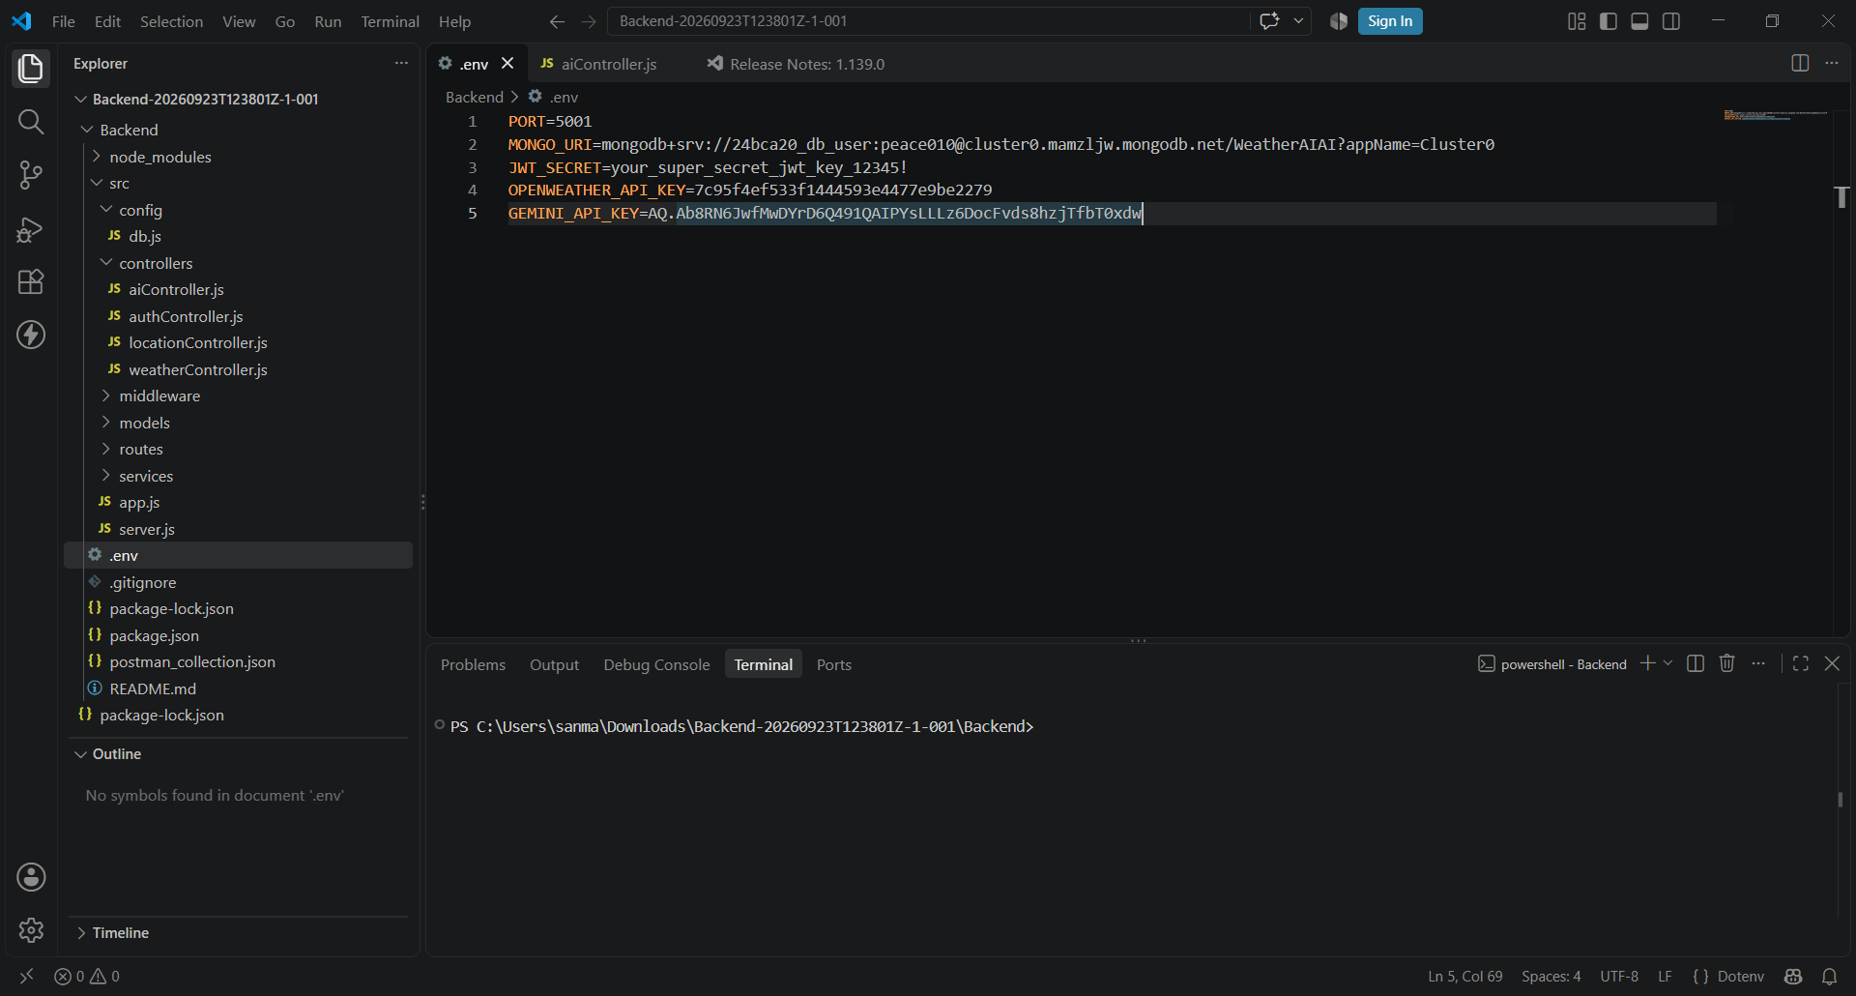
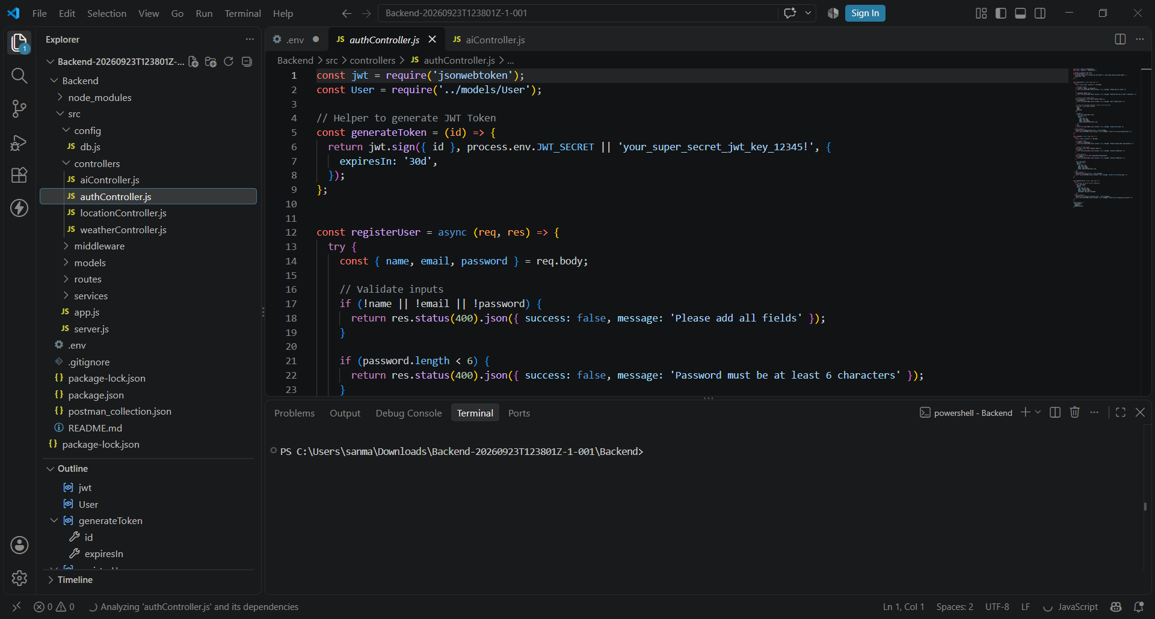

6. System Architecture
User
↓
Frontend Interface
↓
Express.js Server
↓
Weather API ↔ MongoDB Atlas
↓
Weather Results
↓
User

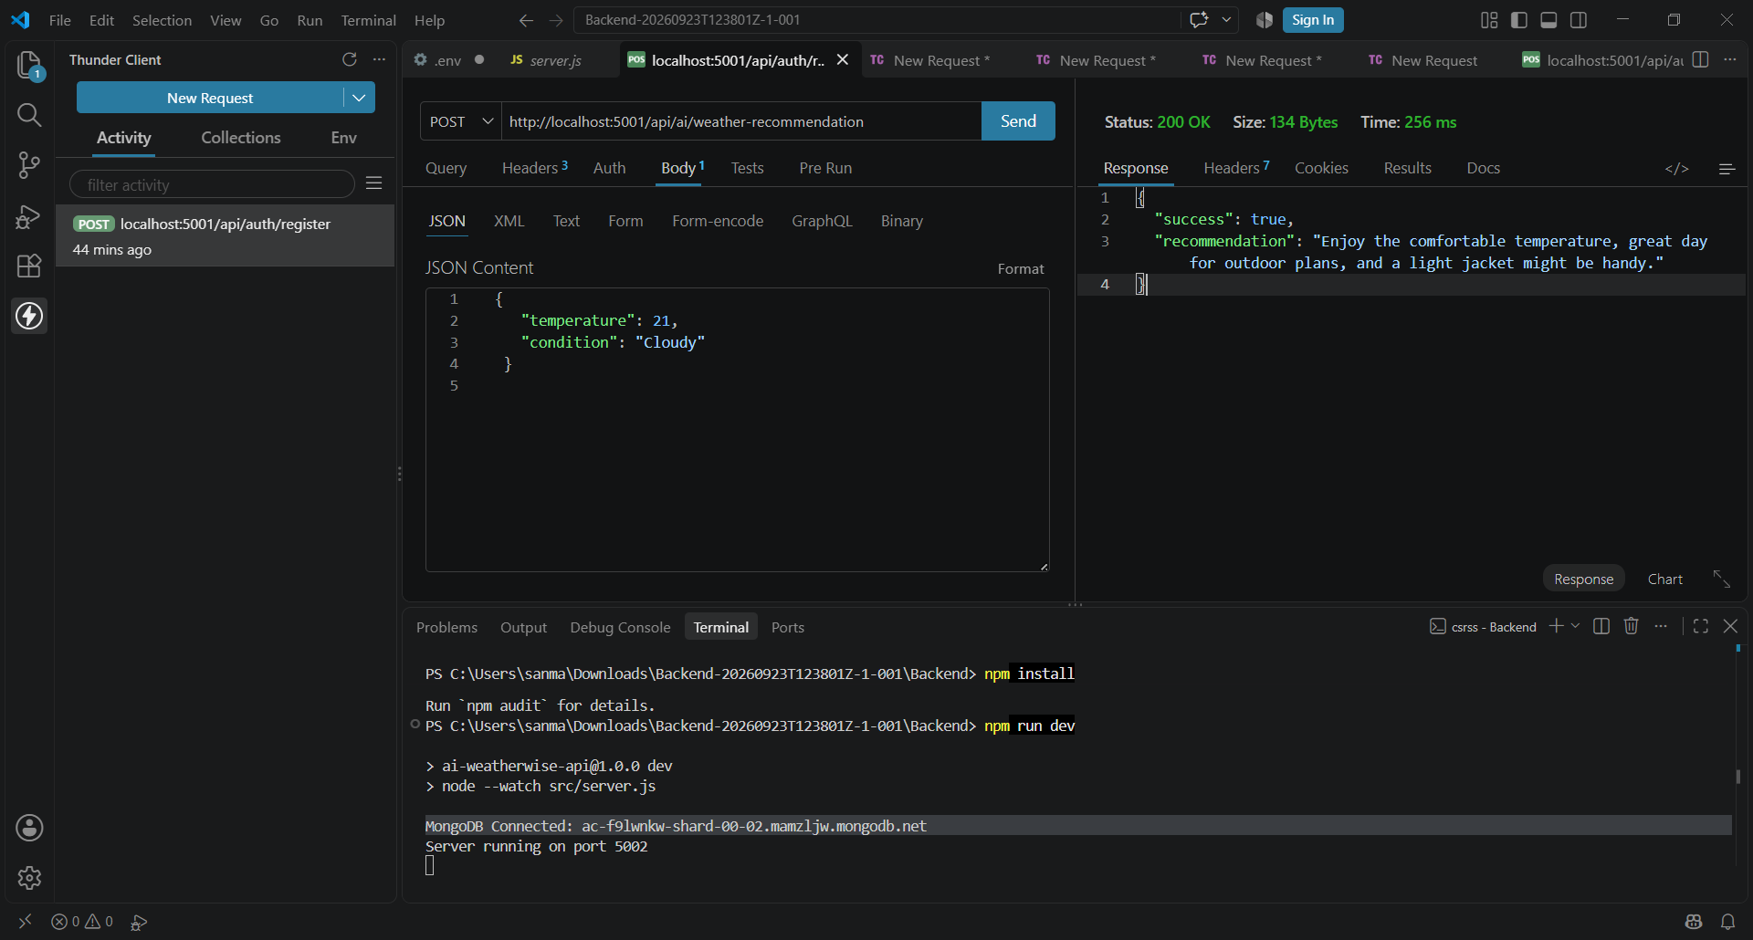
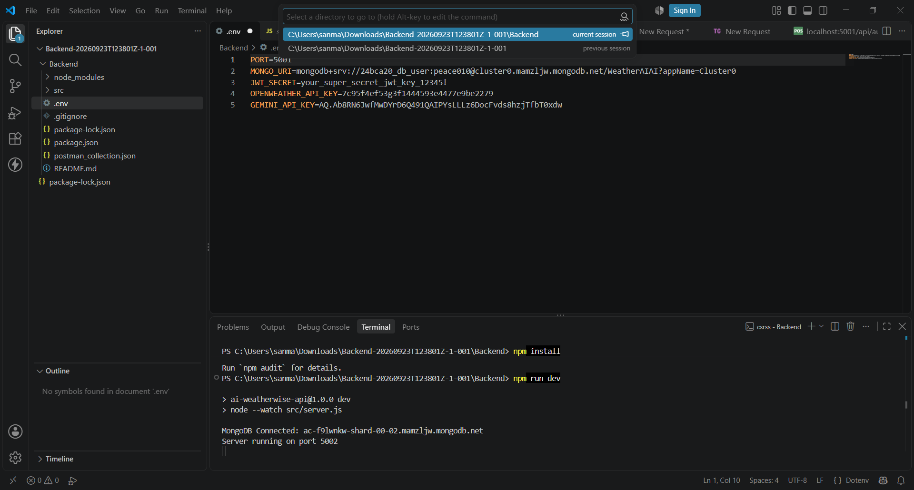

7. Modules Description

Module 1: User Interface
- Accepts user input.
- Displays weather information.
- Provides responsive design.

Module 2: Weather API Integration
- Connects to weather APIs.
- Retrieves weather data.
- Processes API responses.

Module 3: Database Management
- Stores application data.
- Retrieves stored records.
- Maintains database integrity.

Module 4: Backend Services
- Handles requests and responses.
- Manages routing.
- Ensures server functionality.

8. Database Design

Database Name
WeatherWiseAI

Users Collection
Field Name | Data Type
_id | ObjectId
Name | String
Email | String
Password | String

Weather Collection
Field Name | Data Type
_id | ObjectId
City | String
Temperature | Number
Humidity | Number
WindSpeed | Number
Pressure | Number
Condition | String
Timestamp | Date

9. Features
- Real-time weather updates
- Location-based weather search
- Temperature monitoring
- Humidity tracking
- Wind speed information
- Atmospheric pressure details
- API integration
- MongoDB cloud database support

10. Project Workflow
- User enters a location.
- Request is sent to the server.
- Weather API is called.
- Data is retrieved and processed.
- Information is stored if required.
- Weather details are displayed to the user.

11. Advantages
- Easy to use
- Accurate weather information
- Fast response time
- Scalable architecture
- Cloud database integration

12. Limitations
- Requires internet connectivity.
- Depends on third-party weather APIs.
- Limited offline functionality.

13. Future Enhancements
- AI-based weather prediction
- Air Quality Index integration
- Severe weather alerts
- Mobile application support
- Voice assistant integration

14. Conclusion
AI WeatherWise API is an efficient weather forecasting and monitoring system that provides accurate weather information through API integration and cloud database support. The project demonstrates practical implementation of full-stack web development concepts and offers a foundation for future AI-powered weather prediction systems.

15. References
- Node.js Documentation
- Express.js Documentation
- MongoDB Atlas Documentation
- Weather API Documentation
- MDN Web Documentation

